Q 2  
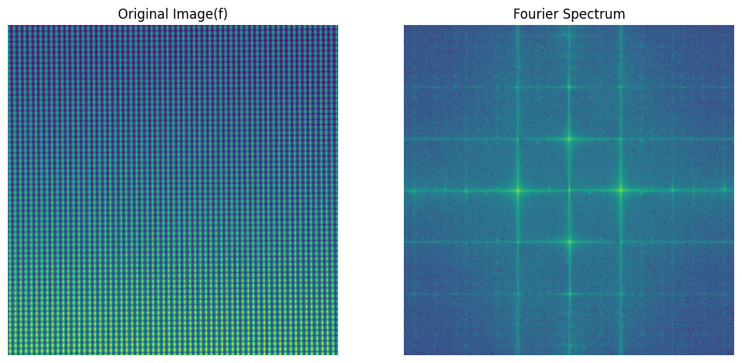

Fig 01. Original image on left side and their Fourier transforms on right side. Clearly, we can see periodicity is visible as spikes.

Part a

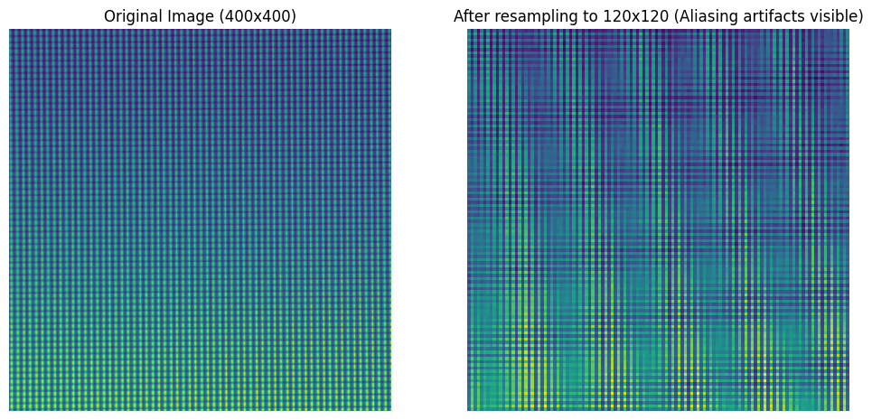

Fig 02. Rescaled the original image by scaling factor of 0.3.

In the right image of Fig 02, the aliasing start visible on scaling down the original image by a factor of 0.3 using bilinear interpolation.

Part b

Let $f_{x}$& $f_{y}$ original sampling frequency in horizontal and vertical direction respectively.

$S_{x}$: Scaling factor in horizontal direction

$S_{y}$: Scaling factor in vertical direction

In the horizontal direction, the cutoff frequency, $D_{ox}$ = $\frac{f_{x} }{2S_{x}}$

In the vertical direction, the cutoff frequency, $D_{oy}$ = $\frac{f_{y} }{2S_{y}}$

Applied the Gaussian low pass filter on frequency domain of original image ‘f’. The result are shown in fig 03.

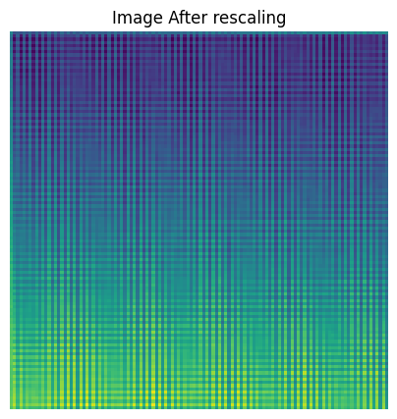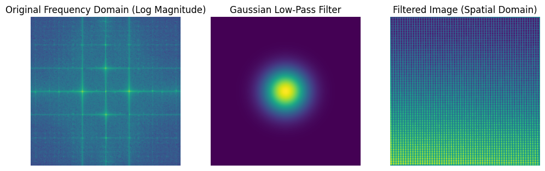

AB

CD

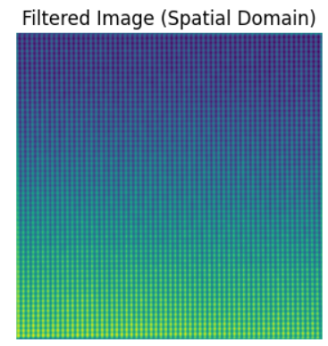 Fig 03. Applied the Gaussian low pass filter on frequency domain of ‘f’.

In Fig 03, the Gaussian low pass filter applied on frequency domain of ‘f’. The image ‘C’ is filtered image after bringing it to spatial domain and ‘D’ are after rescaling it (same thing as in part A). We can see that after applying the low pass filter on ‘f’, the aliasing artifacts almost gone.

Part C

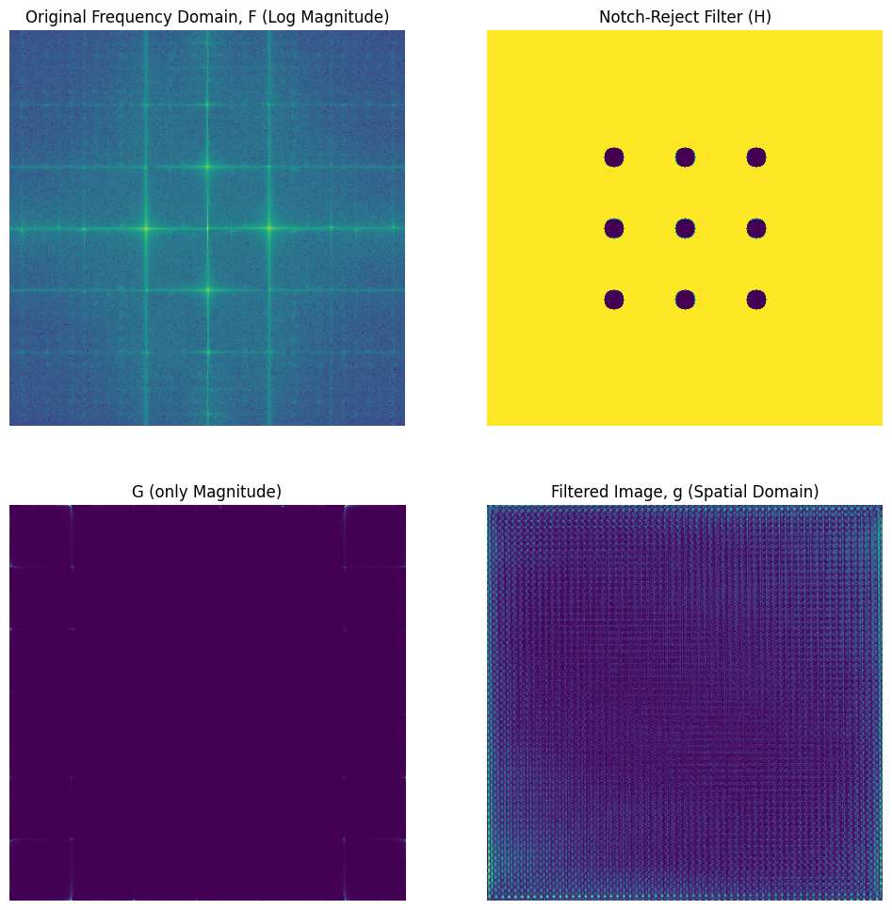

AB

CD

Fig 04. Applied notch-reject filter ‘H’ on ‘F’.

Defined a notch-reject filter as explained below.

Part D

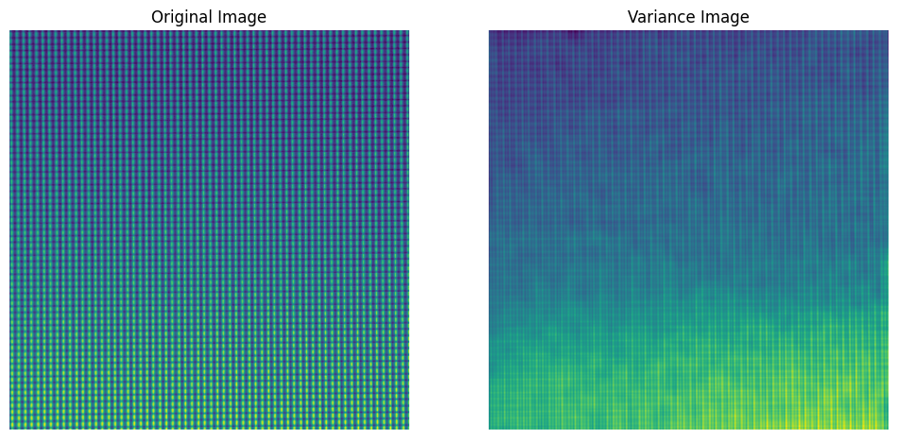

Fig 05. Computed the ${Var}_{x,y}$ (f) using the sliding windows of size 15x15.

Part E

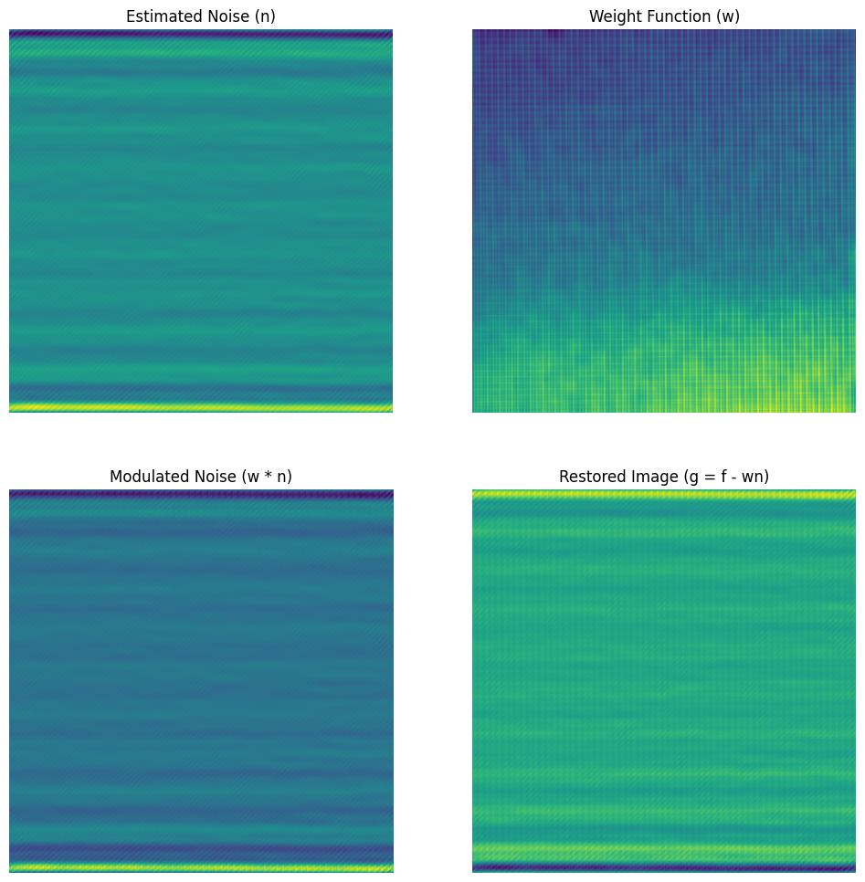

AB

CD

Fig 06. Performed optimum notch filtering

**Q 3**

Part a

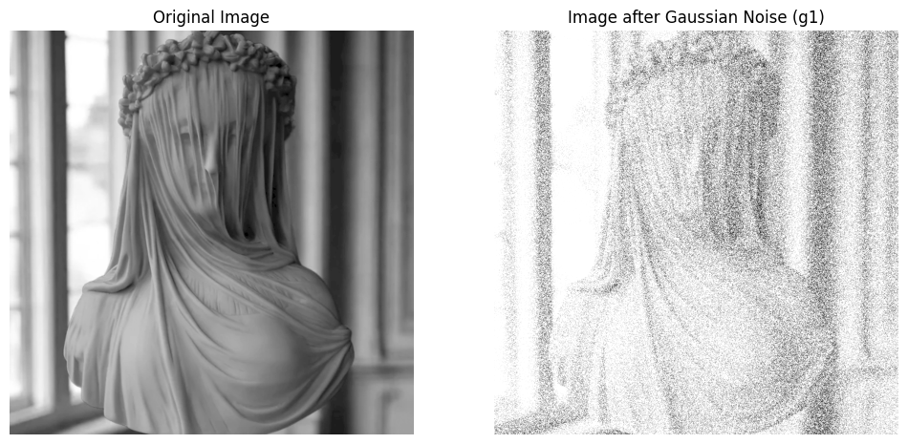

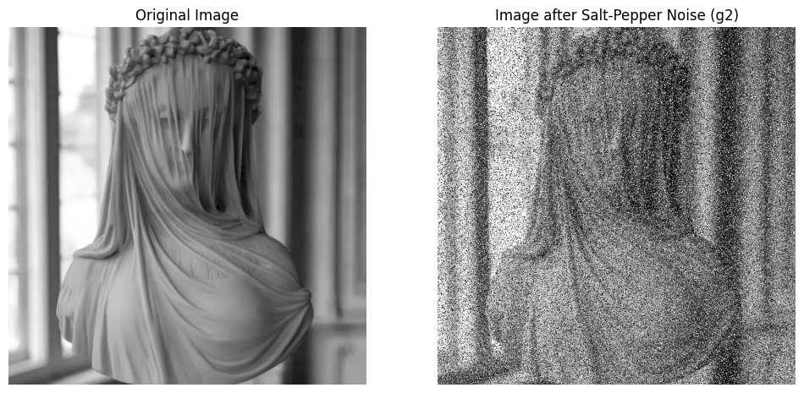

Fig 07. A & C are same. B is created by adding Gaussian noise to A and D is created by adding Salt-Pepper noise to C.

AB

CD

Part B

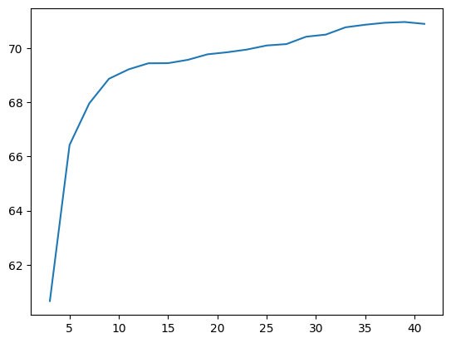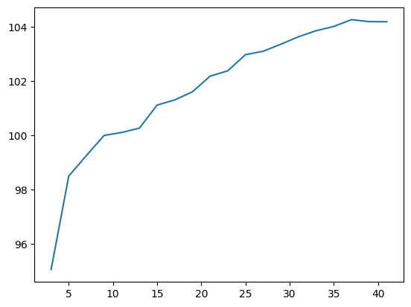Mean and Median filter on g1

MSE

MSE

W W

Fig 05. MSE of median filter on g1

Fig 04. MSE of mean filter on g1

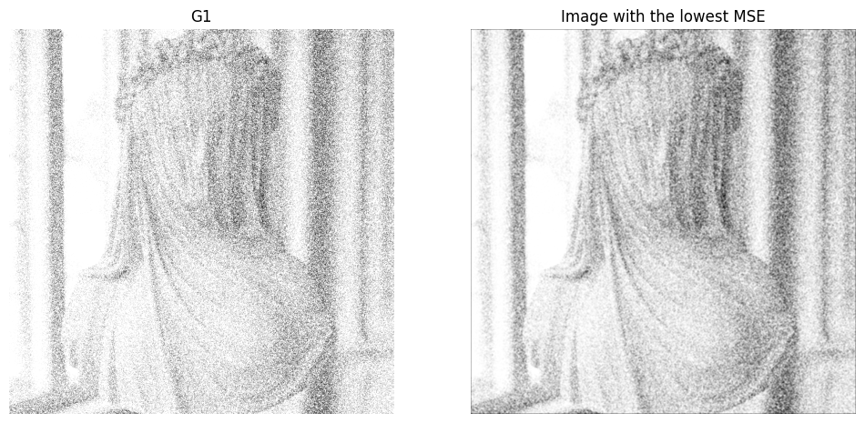

Fig 06. Right image: Mean filter on g1 with minimum MSE (best resulting image)

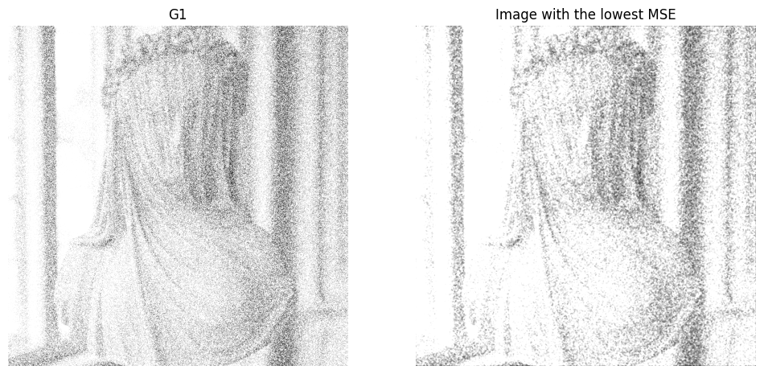

Fig 07. Left image: g1 and Right image: Median filter on g1 with minimum MSE (best resulting image)

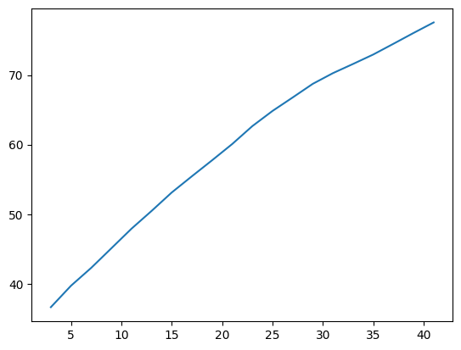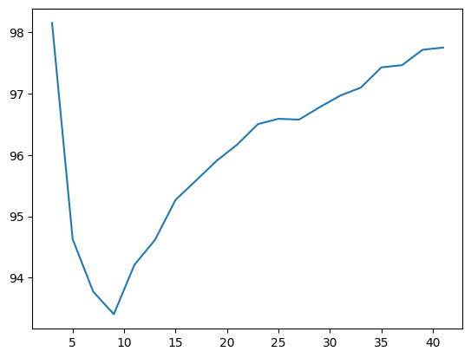Mean and Median filter on g2

MSE

MSE

W W

Fig 04. MSE of mean filter on g2 Fig 05. MSE of median filter on g2

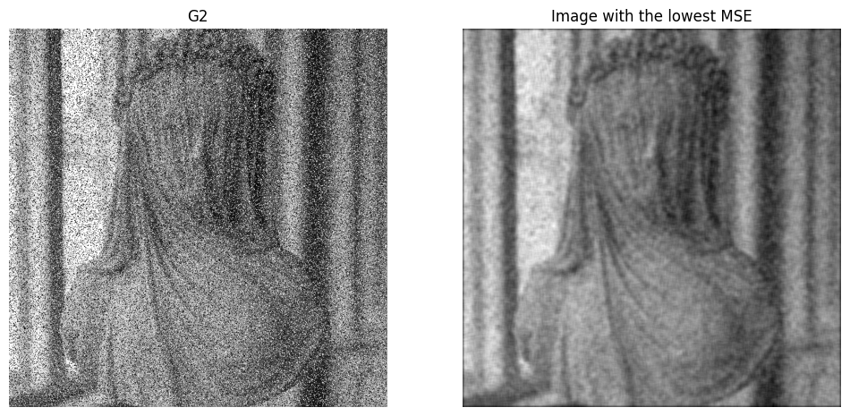

Fig 06. Right image: Mean filter on g2 with minimum MSE (best resulting image)

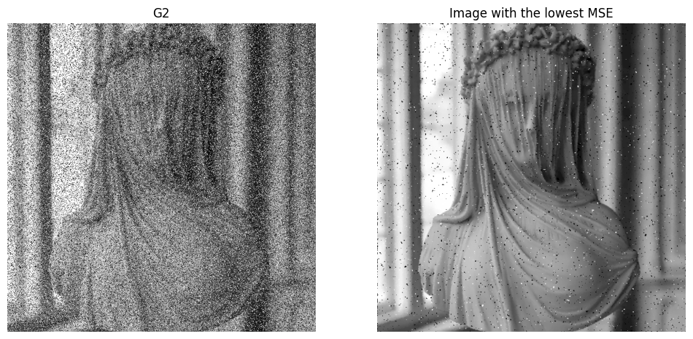

Fig 07. Median filter on g1 with minimum MSE

Fig 07. Right image: Median filter on g2 with minimum MSE (best resulting image)

Part C

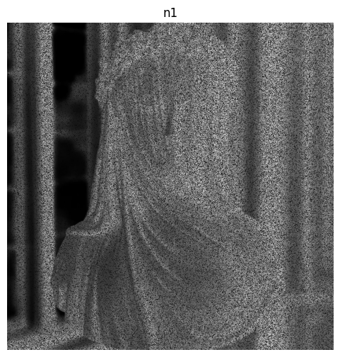Part C

Fig 08. Gaussian noise image, n1 = g1 - f

Fig 08. Gaussian noise image, n1= g1-f.

Part D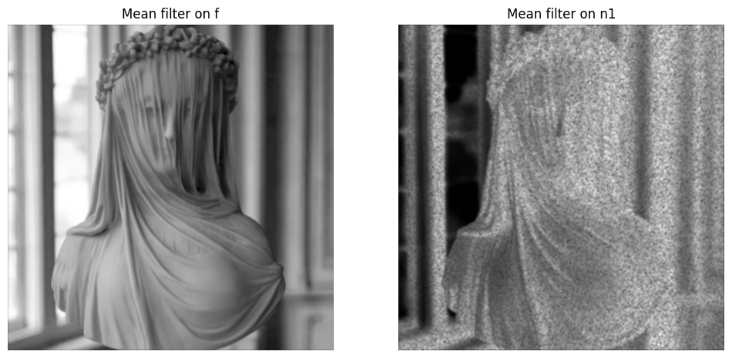

Fig 09. Left Image: Mean filter on f. Right Image: Mean filter on n1. In both image w=5.

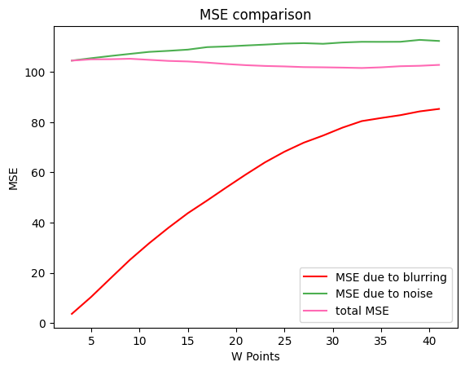 Fig 10. MSE comparison

Observation:

1. MSE due to blurring increasing as the kernel size w increases since larger filters cause more blurring.
2. MSE due to noise gradually increasing with increasing w.
3. Total MSE is first decreased (due to noise reduction) and then increase (due to excessive blurring), explaining the observed behaviour when you vary w.